Policy Name | Research Excellence Awards Policy
Proposed By | Director ORIC
Reviewed By | Registrar and Pro-VC
Approved By | ORIC Steering Committee
Effective From | 01-07-2026
Next Review Date | 30-06-2028
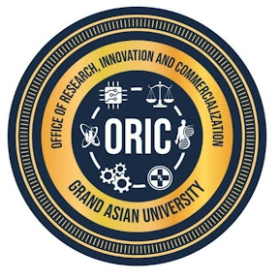
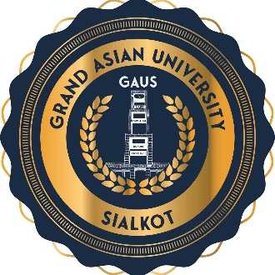

- Preamble
Research excellence is fundamental to the University's mission of advancing knowledge, fostering innovation, and contributing to sustainable national and global development. This policy establishes a transparent, merit-based framework for recognizing exceptional research achievements by faculty members, researchers, students, and research teams. The awards celebrate excellence across the entire research and innovation ecosystem, including publications, citations, commercialization, external funding, interdisciplinary collaboration, mentorship, and societal impact.
- Purpose
The purpose of this policy is to:
- Encourage researchers by recognizing and rewarding outstanding research performance
- Increase research quality and impact by encouraging publications in internationally reputed journals
- Enhance citation performance by promoting high-impact and interdisciplinary research
- Improve global university rankings by enhancing the University's national and international visibility
- Research Award Categories
Sr. | Award Category | Eligibility | Cash Reward
1 | World's Top 2% Scientists Award | Inclusion in Stanford World's Top 2% Scientists List | 25,000
2 | Nature Index Publication Award | Publication in Nature Index journals | 25,000
3 | Outstanding Research Grant Award | Largest competitive national or international research grant secured | 20,000
4 | Innovation & Patent Award | Granted patent or commercialized innovation | 20,000
5 | High Impact Journal Award | Publication in journals with Impact Factor ≥07 for Sciences and ≥03 for Social Sciences | 15,000
6 | Highest Publication Award | Highest number of Scopus/WoS indexed publications in a calendar year (minimum 05) | 15,000
7 | Highly Cited Paper | Inclusion in list of highly cited papers by WoS or certificate issues by the Journal | 15,000
8 | Best Researcher Award | Outstanding researcher according to the evaluation criteria | 15,000
9 | Young Researcher Award | Outstanding researcher below 40 years of age or within 10 years of PhD | 15,000
10 | Policy Impact Award | Outstanding policy paper adopted by a government or international organization | 15,000

- Selection Process
- ORIC shall invite nominations annually.
- Applications shall be supported by documentary evidence.
- A Research Awards Committee shall evaluate all nominations using transparent and merit-based criteria.
- Recommendations shall be approved by the Vice Chancellor.
- Awards shall be presented during the Annual Research and Innovation Awards Ceremony.

- General Conditions
- A faculty member may receive more than one award in a year if eligible.
- Publications, citations, grants, and patents must be verifiable through recognized databases or official documentation.
- Publications in predatory journals shall not be considered.
- Any researcher found guilty of research misconduct shall be ineligible for awards for a period determined by the University.
- The University reserves the right not to confer an award if no candidate meets the required standard.
- Policy Review and Amendments
This policy shall be reviewed every two years, or earlier if required, to ensure alignment with the University's strategic priorities, HEC regulations, emerging technologies, and best international practices. Amendments shall be approved by the appropriate statutory bodies of the University.

Proposed By: Approved By:

Director ORIC Vice Chancellor/ Chairman ORIC-SC
Grand Asian University Sialkot Grand Asian University Sialkot

